

DEPI Graduation Project

Group A
Project name: Sales analytics & insights
Olist E-Commerce Sales Analysis
“Brazil Market Insights”

Team creation:
- Team size: 3 persons
- Team Structure:
  - Team leader: Peter Gamal
  - Team member: Safa Hassan
  - Team member: Mohammed Hussein

Project selection:
We chose Olist dataset
- This dataset was publicly released by Olist on Kaggle and contains real commercial data, fully anonymised, covering 100,000 orders placed between September 2016 and October 2018 across multiple marketplaces in Brazil.
- Its features allow viewing an order from multiple dimensions: from order status, price, payment and freight performance to customer location, product attributes and finally reviews written by customers.
- It is one of the most complete and richest e-commerce datasets available in the public domain and that is exactly why we chose it.

How it works?
- Olist connects small businesses from all over Brazil to channels without hassle and with a single contract. Those merchants are able to sell their products through the Olist Store and ship them directly to the customers using Olist logistics partners. See more on our website: www.olist.com
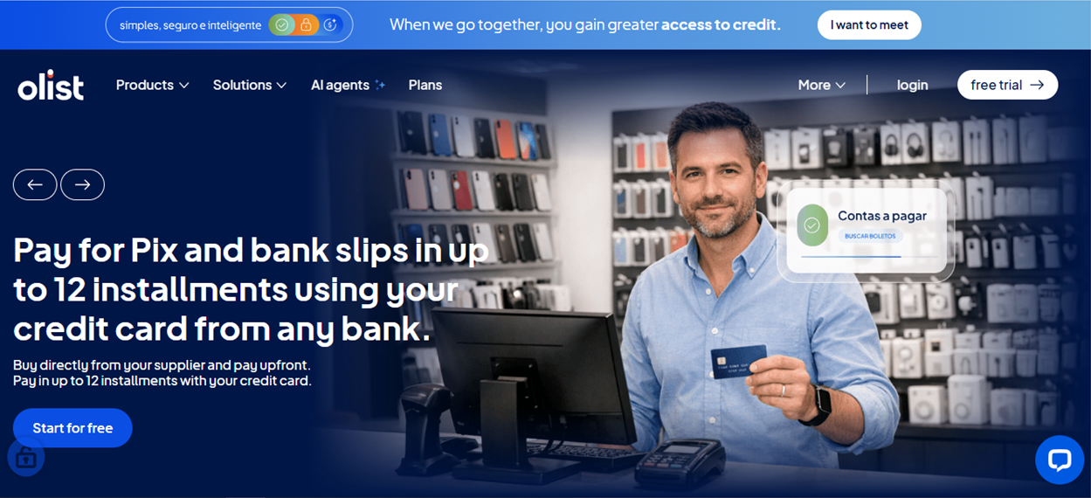
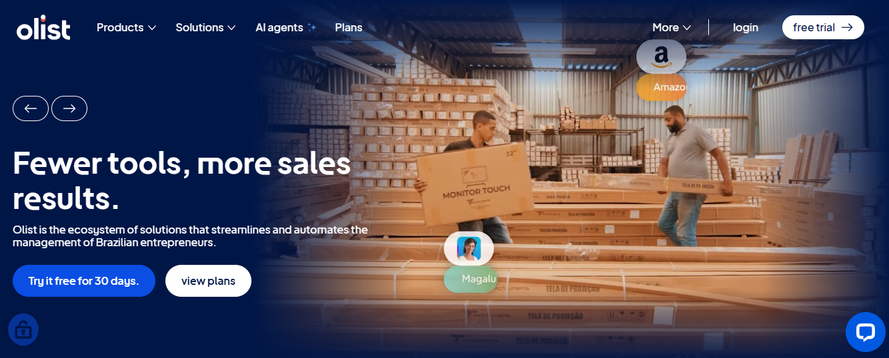
- After a customer purchases the product from Olist Store a seller gets notified to fulfill that order. Once the customer receives the product, or the estimated delivery date is due, the customer gets a satisfaction survey by email where he can give a note for the purchase experience and write down some comments.

Attention
- An order might have multiple items.
- Each item might be fulfilled by a distinct seller.
- All text identifying stores and partners where replaced by the names of Game of Thrones great houses.
Example of a product listing on a marketplace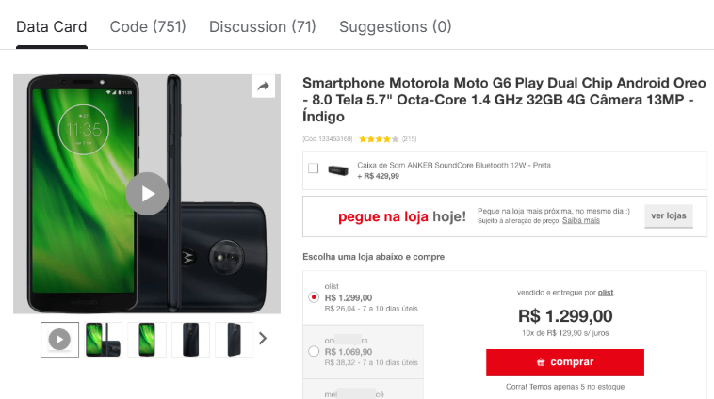

Why olist?
Here is the first thing that makes this dataset interesting and challenging at the same time:
- The data does not come in one file. It comes in nine.
- Nine files. Hundreds of columns. Nearly 1.5 million rows of data across all files combined.
- Before any analysis could happen, all nine files had to be understood individually, audited for quality, and then carefully merged into a single master dataframe which we named olist_df.
- That merge is not a one liner. It requires knowing which files connect to which, through which keys, and in which order. The full preprocessing and merging pipeline is documented step by step in this notebook.

Project planning and management:
  - Problem statement – data cleaning:
- Blank and duplicates removed
- Special characters in city names, some cities once written as “são paulo” and other times “sao paulo” , altinópolis & altinopolis, Alvinlândia & alvinlandia, etc and many others á é ê ú ô ç , so we replaced these characters with letters.

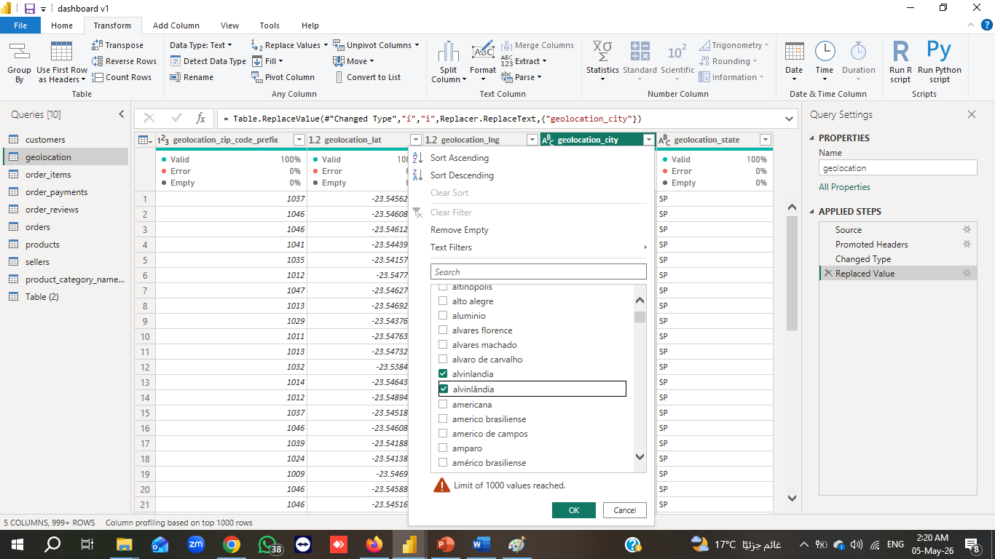
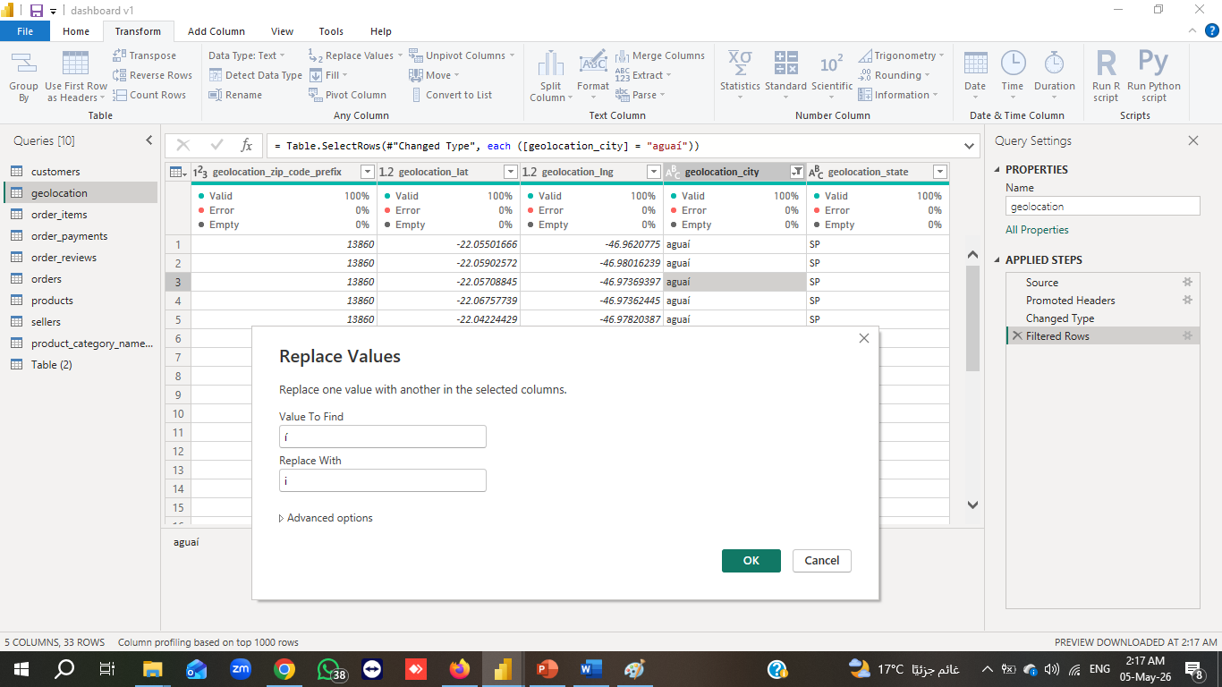
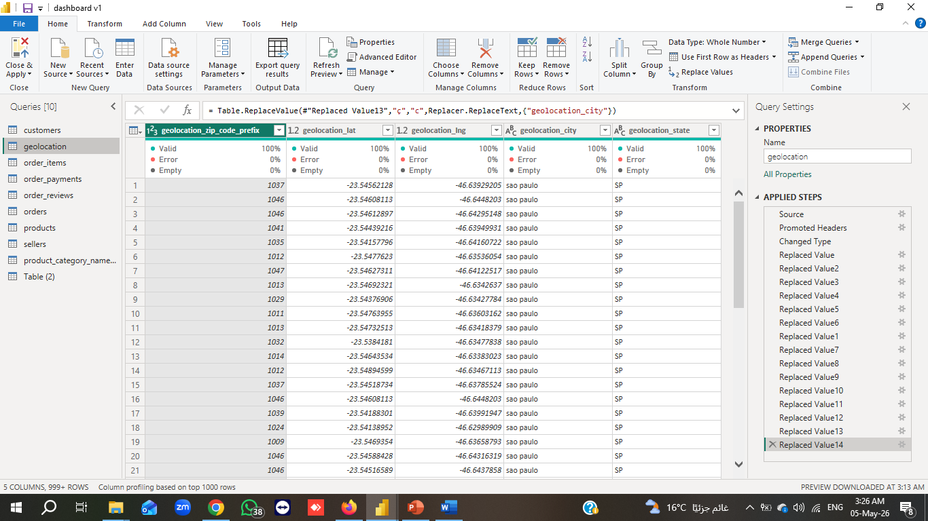

- Connecting all tables:
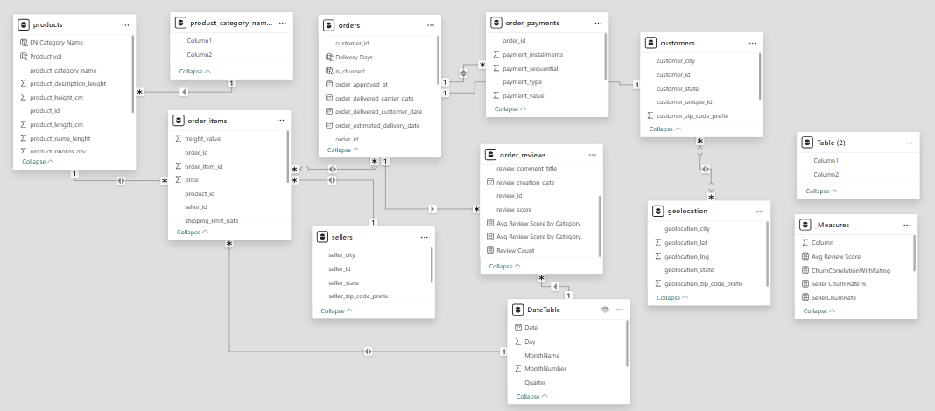

We have used
- Python (Pandas, Matplotlib, Seaborn) for the initial data cleaning and explorations
- Jupyter Notebook – For documenting analysis steps.
- SQL for creating the database and queries
- Power BI for the data visualization, interactive dashboards.
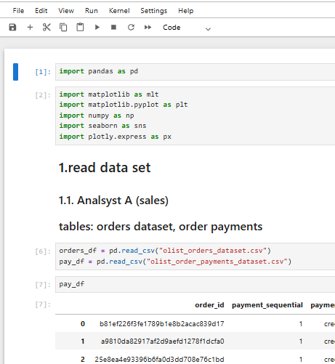
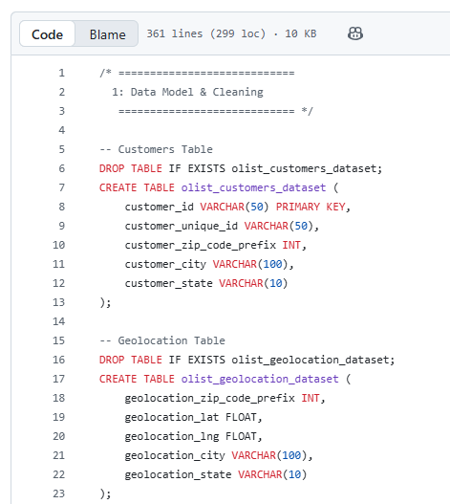
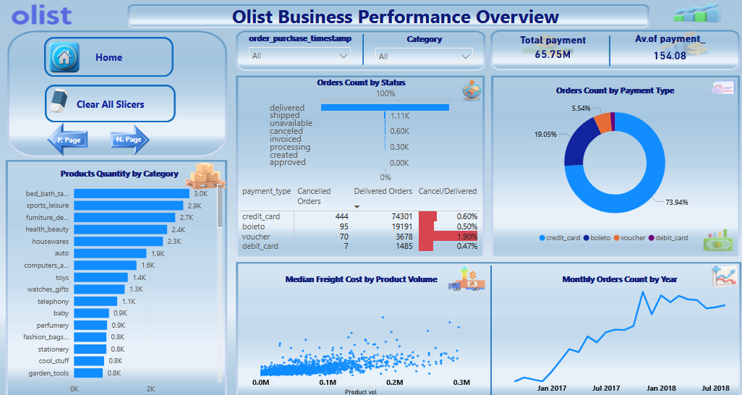

What we have found

1. Sales & Growth: The "Black Friday" Effect

- 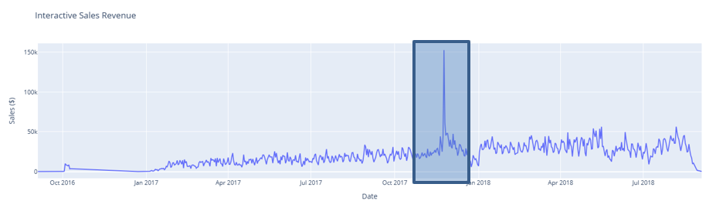The marketplace experienced a permanent baseline shift following November 2017. This "Black Friday Breakout" acted as a mass acquisition event, moving the "normal" daily sales floor from negligible levels to a steady $20k–$50k plateau.
- 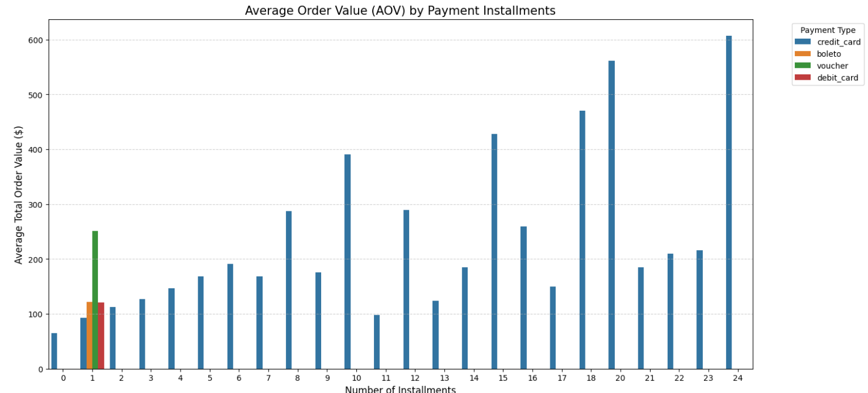Revenue Driver: Credit Card installments are the engine of high-ticket sales. Orders over $300 almost exclusively rely on 10–24 installment plans. Without these, the average order value (AOV) for premium items would likely collapse.

2. Logistics: The "Northeast" Challenge
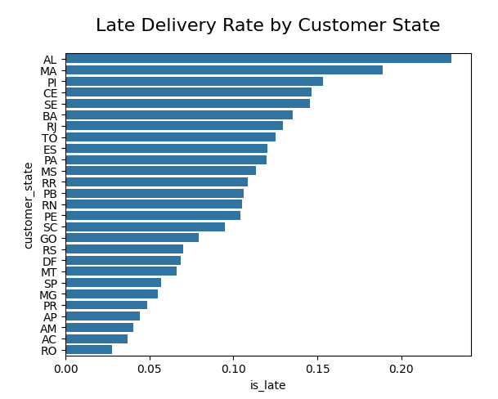
Delivery performance is regional. States in the Northeast (AL, MA, PI) “Alagoas, Maranhao, Piaui” face late delivery rates as high as 23%, compared to the best performer (RO) “Rondonia” at under 3%.
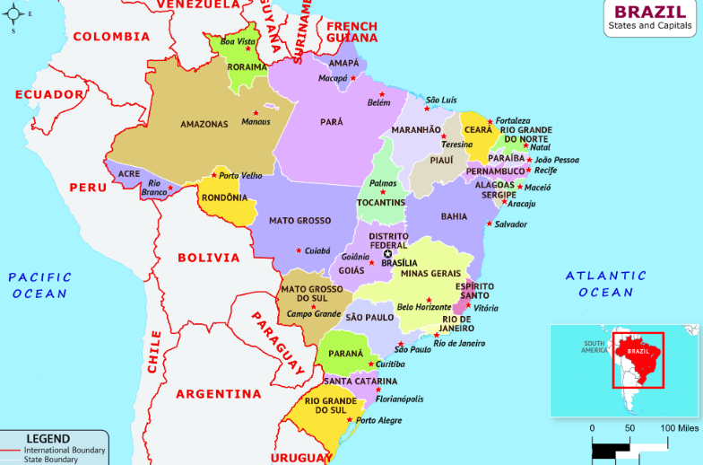
- There is a weak negative correlation (-0.27) between delays and customer ratings. While lateness hurts, it isn't the only driver of bad reviews—suggesting that product quality or description accuracy is equally critical.

3. Seller Health: "Healthy" vs. "Structural" Churn
The overall churn rate of 41.87% is misleadingly high because the marketplace is "self-cleaning."
- The Good: 80% of low-rated sellers (1-2 stars) leave the platform naturally.
- The Bad: We have a "Growth Leak" in the Mid-Tier segment (sellers with 3–50 sales) where churn is 48%.
- The Urgent: Top-tier sellers have a 34% structural churn. Since they have high ratings, they aren't leaving because of poor sales; they are likely leaving due to fees or better offers from competitors.

Payment preferences
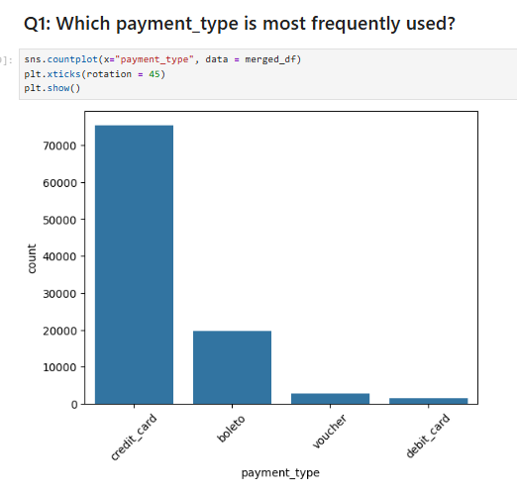
The payment method with the greatest revenue potential for Olist is credit card payments because:
- They already represent the largest share of transactions (~74%).
- Credit card users are more likely to make impulse and high-value purchases.
- Installment options encourage customers to spend more per order.
- Payments are approved instantly, reducing order cancellation risk compared to boleto.
- They support recurring purchases, loyalty programs, and upselling strategies more effectively.
From a business perspective, increasing credit card conversion and average ticket size would likely generate the highest revenue impact.
However, vouchers have the highest cancellation rate:
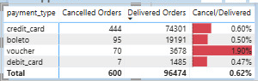

5. Strategic Action Plan (The "What Should We Do")

Objective | Recommended Action | Expected Outcome
Fix Data Quality | Make category selection mandatory during onboarding to fix the 91% churn in "Unknown" categories. | Immediate reduction in total churn average.
Plug Growth Leak | Investigate and reduce the 48% churn in Mid-Tier sellers (e.g., lower fees for scaling up). | Organic growth of Top-Tier sellers without acquisition costs.
Protect Top Sellers | Conduct exit interviews for 4-5 star sellers. Review commission structures for low-margin niches like Electronics. | Retention of the platform’s "Lifeblood" (Top 462 sellers).
Optimize Logistics | Partner with local warehouses (3PL) in the Northeast region to reduce the 23% late rate. | Increased customer LTV (Lifetime Value) and higher average review scores.
Reduce voucher cancellation rate | Limit voucher usage to low-risk users/orders; add expiry dates, minimum purchase value, and targeted incentives for switching to stable payment methods | Lower cancellation rate, reduced fraudulent/low-intent orders, and improved order completion rate
Increase revenue from dominant payment method | Increase partnerships with credit card providers offering installments, cashback, and loyalty rewards | Higher average order value and increased repeat purchases

